
SECONDARY
READY

A booklet to get you ready for Secondary School

Additional information

Dear Parents,

Due to Covid -19, transition will look different to previous years. In response to this all secondary schools are making their own arrangements and have been/will be in touch with you individually.

To help with this I have also put together a few activities below that will be useful as discussion points for you and your child to think about and to work through.

In addition, I have included the website details for the schools our children are attending. ( I have included the specific link where this has been provided by the school) . The websites include virtual tours and lots of presentations from key staff..

Littleover Community School: http://www.littleover.derby.sch.uk/induction.php

Merrill Academy: https://www.merrillacademy.derby.sch.uk/whats-happening/transition

Bemrose: http://www.bemrose.derby.sch.uk/year-6-7-transition/

Murray Park: http://www.murraypark.derby.sch.uk/

City of Derby: http://www.cityofderbyacademy.org/

Derby Moor Academy: http://www.derbymoor.derby.sch.uk/Parents/Transition-Process/

Landau Forte College Derby: https://landau-forte.org.uk/

Noel Baker Academy: https://www.noelbakeracademy.co.uk/transition-2/

Saint Benedict: http://saintben.derby.sch.uk/content/y7-2020/

Lees Brook: http://www.leesbrook.co.uk/index.php/admissions/transition-task-1

Allestree Woodlands: https://www.dropbox.com/sh/2q77uahlvc8ijl6/AAC1e1R3Nkp5hA5B3mZfyvVua?dl=0

BBC Bitesize also have some useful information on transition and videos that you and your child can watch.

https://www.bbc.co.uk/bitesize/tags/zh4wy9q/starting-secondary-school/1


I am ………………… years old
My favourite colour is …………………
I have these pets………………………
My favourite subject is ………………
A word that describes me is
…………………………………………
A Picture of Me!
My Family
My Hobbies
Things I don’t like!

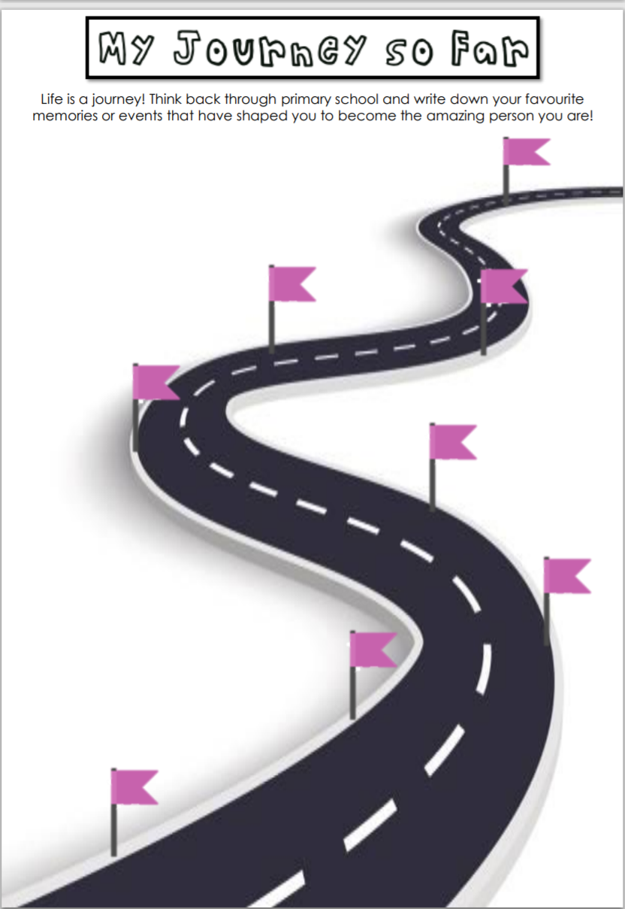

Getting ready for Secondary school

Follow the steps below to get yourself organised.

Take your PE kits to secondary school on
the day you have sports activities.
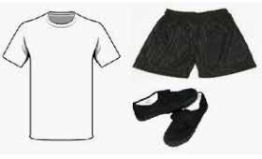

Take your own stationery in a pencil case. Please take x2 pencils, a pen, ruler, rubber and a sharpener as a minimum.

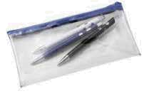

Everything must be taken home every day – not left in classrooms.

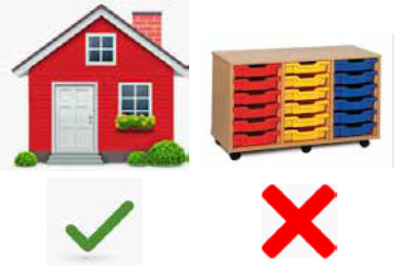

All work books in the correct boxes according to the subject.
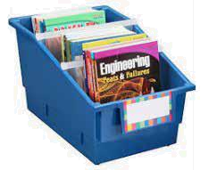


Planner with timetable on desk.



My Journey to school ( Use the secondary school website to help you)

What do you need to know about getting there?

Use google maps to research and help you write instructions or draw a picture to show how you will get there.



What if... What would you do?


You have

missed
the bus?

Your friend
hasn’t waited

for you?

Uniform

Items of uniform that I need to wear?

Draw a picture of the school uniform.




Scenario Cards

Use the scenarios cards to have a discussion with your child.
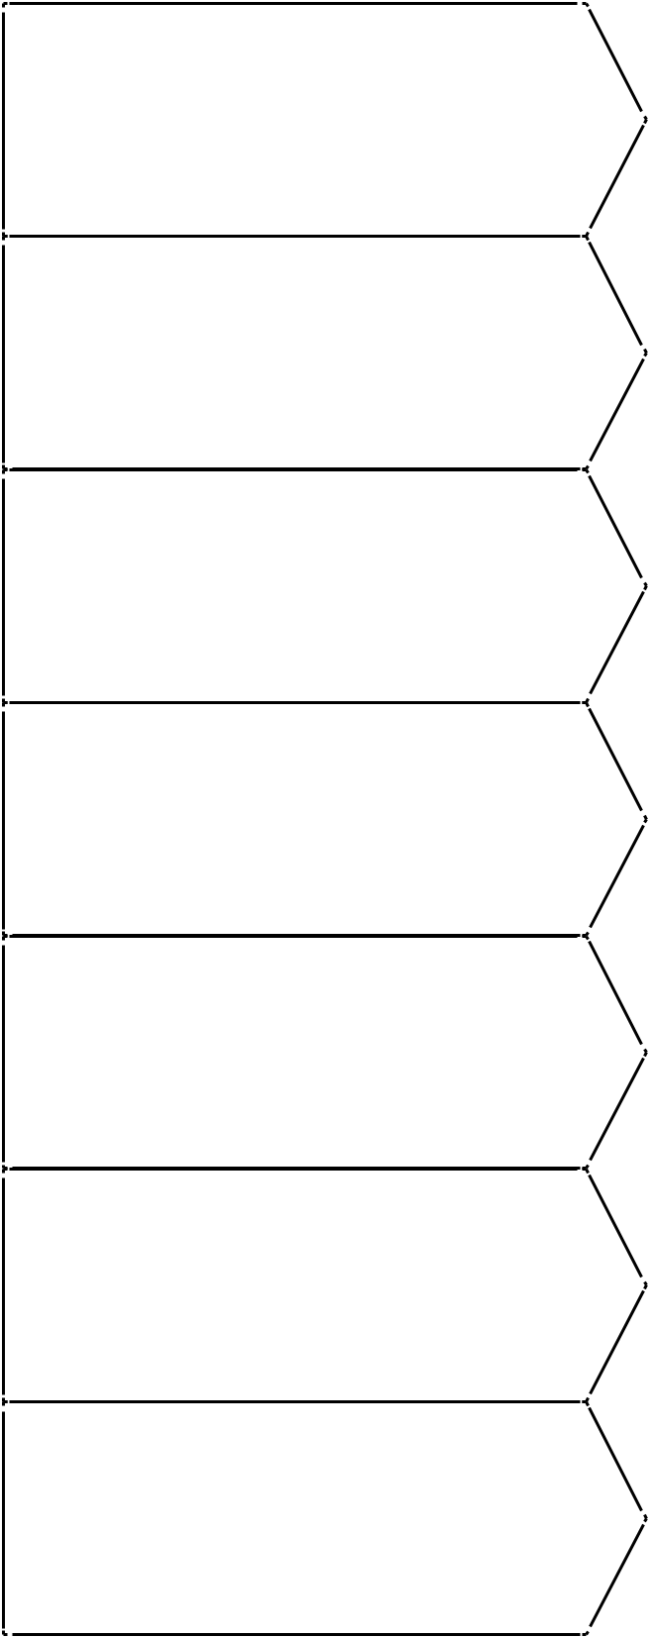

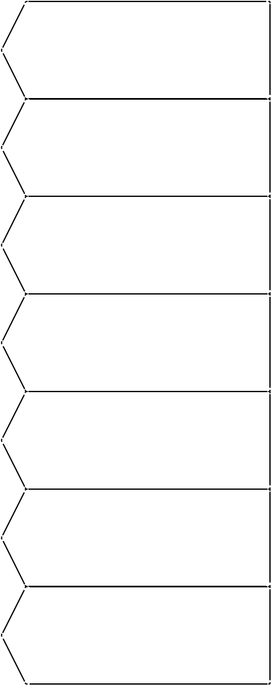
What do I do if I can’t

remember where my

classroom is?

What happens if I

forget my pencil case?

I have forgotten my

lunch:

I don’t know what

class I have next.

What happens if I

forget my homework?

What happens if I

forget my PE kit?

I have no friends to

talk to

- Ask an adult

- Use my planner. Timetable and map and work it out
- Go to reception or student services

- Tell your form tutor and ask to borrow one
- Ask a friend if they can lend you a pen and pencil

- Tell your form tutor

- Ask school to contact home to see if a parent can bring it in
- Borrow some money from school and have a dinner

- Check your timetable

- Ask at the school office

- Tell your form tutor

- Tell the teacher that set the homework and
- say you will bring it in tomorrow

- Tell your form tutor

- Ask school to call home to see if a parent can bring it to school
- Borrow kit

- Tell your form tutor

- Tell your Head of Year

- Try talking to someone you like

- Try talking to an older student mentor

5

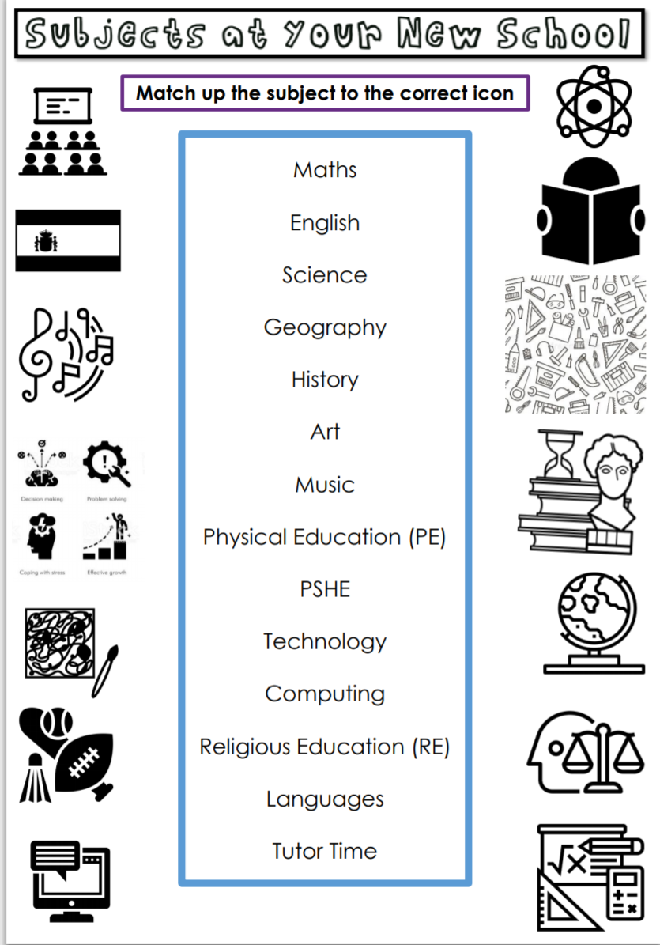

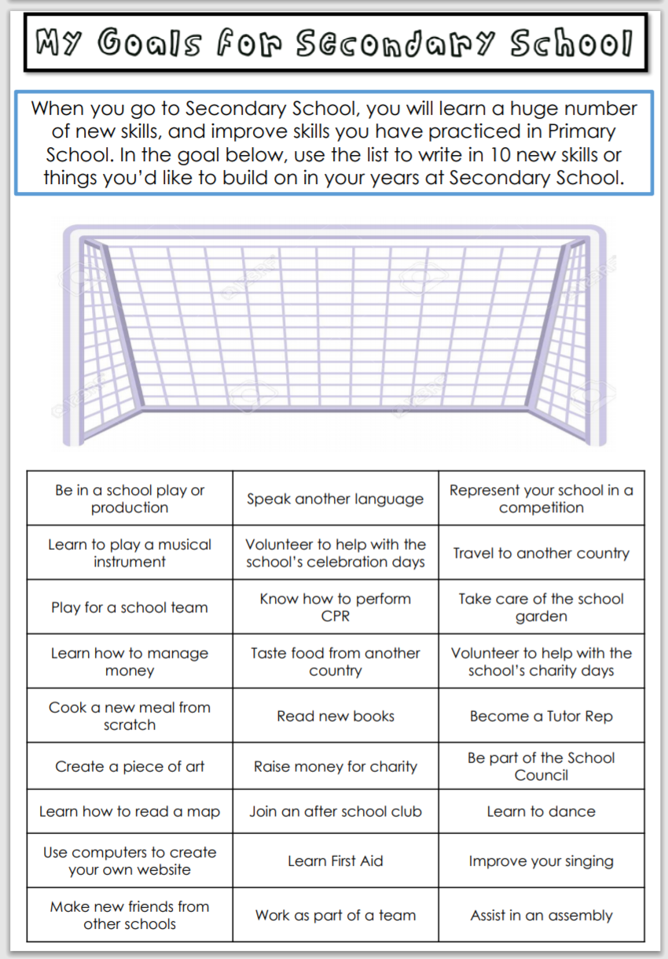

Use the secondary school website to find out the timings for your school..

School times
8
7
10
11
9
5
4
1
2
6
12

Lunch time is at:
_ _: _ _

3
8
7
10
11
9
5
4
1
2
6
12

School starts at:
_ _: _ _

3
8
7
10
11
9
5
4
1
2
6
12

Break time is at:
_ _: _ _

3
8
7
10
11
9
5
4
1
2
6
12

School finishes at:
_ _: _ _

3
School times


